
Foundation University Islamabad
School of Science and Technology

Name: Hunaina Yasir Roll Number: 073
Subject: PF Lab Section: B
STRUCTURE LAB EXERCISE
Exercise 1:
Create a structure named Student with members: roll number, name, and GPA. Input data for 3 students and display it.

SOURCE CODE:
#include <iostream>
#include <conio.h>
using namespace std;

struct Student {
int roll;
string name;
float gpa;
};

int main() {
cout << "Hunaina Yasir" << endl;
cout << "Roll number: 073" << endl << endl;

Student s[3];

for (int i = 0; i < 3; i++) {
cout << "Enter roll number: ";
cin >> s[i].roll;

cout << "Enter name: ";
cin >> s[i].name;

cout << "Enter GPA: ";
cin >> s[i].gpa;

cout << endl;
}

cout << "Student Data" << endl << endl;

for (int i = 0; i < 3; i++) {
cout << "Roll Number: " << s[i].roll << endl;
cout << "Name: " << s[i].name << endl;
cout << "GPA: " << s[i].gpa << endl << endl;
}

return 0;
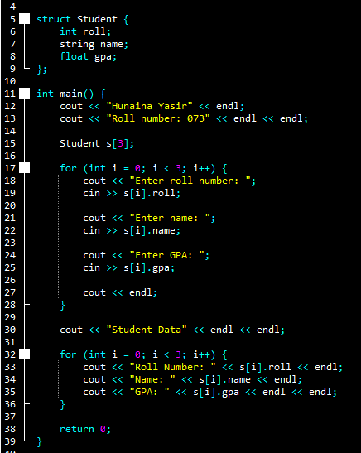
}

OUTPUT:
Hunaina Yasir
Roll number: 073

Enter roll number: 8
Enter name: sia
Enter GPA: 3.4

Enter roll number: 56
Enter name: jia
Enter GPA: 2.3

Enter roll number: 67
Enter name: ria
Enter GPA: 3.4

Student Data

Roll Number: 8
Name: sia
GPA: 3.4

Roll Number: 56
Name: jia
GPA: 2.3

Roll Number: 67
Name: ria
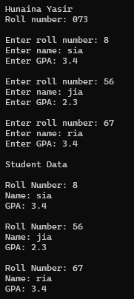
GPA: 3.4
Exercise 2:
Write a program using a structure Employee to calculate and display the annual salary of an employee.

SOURCE CODE:
#include <iostream>
using namespace std;

struct Employee {
string name;
float monthlySalary;
};

int main() {
cout << "Hunaina Yasir" << endl;
cout << "Roll number: 073" << endl << endl;

Employee e;

cout << "Enter name: ";
cin >> e.name;

cout << "Enter monthly salary: ";
cin >> e.monthlySalary;

float annualSalary = e.monthlySalary * 12;

cout << "Annual Salary: " << annualSalary << endl;

return 0;
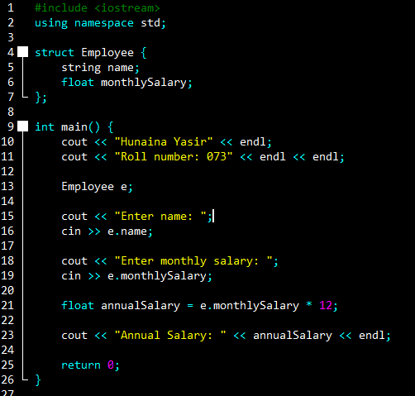
}
OUTPUT:
Hunaina Yasir
Roll number: 073

Enter name: hia
Enter monthly salary: 34000
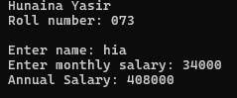
Annual Salary: 408000

Exercise 3:
Create a structure Book and store information for 5 books. Display only those books whose price is greater than 500.
SOURCE CODE:
#include <iostream>
using namespace std;

struct Book {
string title;
float price;
};

int main() {
cout << "Hunaina Yasir" << endl;
cout << "Roll number: 073" << endl << endl;

Book b[5];

for (int i = 0; i < 5; i++) {
cout << "Enter book title: ";
cin >> b[i].title;

cout << "Enter price: ";
cin >> b[i].price;
cout << endl;
}

cout << endl << "Books with price greater than 500:" << endl;

for (int i = 0; i < 5; i++) {
if (b[i].price > 500) {
cout << b[i].title << " " << b[i].price << endl;
}
}

return 0;
}
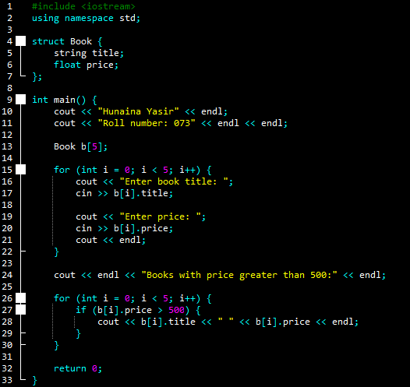
OUTPUT:
Hunaina Yasir
Roll number: 073

Enter book title: the
Enter price: 576

Enter book title: you
Enter price: 876

Enter book title: eta
Enter price: 234

Enter book title: fint
Enter price: 567

Enter book title: ria
Enter price: 123

Books with price greater than 500:
the 576
you 876
fint 567

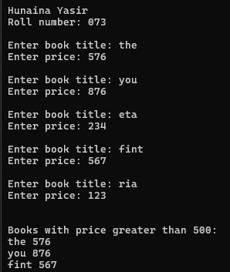
Exercise 4:
Write a program using nested structures to store and display information of a student including date of birth.
SOURCE CODE:
#include <iostream>
using namespace std;

struct Date {
string day;
string month;
int year;
};

struct Student {
string name;
Date dob;
};

int main() {
cout << "Hunaina Yasir" << endl;
cout << "Roll number: 073" << endl << endl;

Student s;

cout << "Enter name: ";
cin >> s.name;

cout << "Enter day of birth: ";
cin >> s.dob.day;

cout << "Enter month of birth: ";
cin >> s.dob.month;

cout << "Enter year of birth: ";
cin >> s.dob.year;

cout << endl;
cout << "Name: " << s.name << endl;
cout << "Date of Birth: " << s.dob.day << " " << s.dob.month << " " << s.dob.year << endl;

return 0;
}
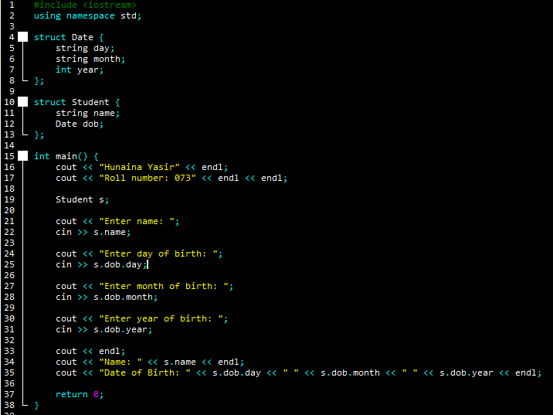
OUTPUT:
Hunaina Yasir
Roll number: 073

Enter name: hian
Enter day of birth: monday
Enter month of birth: may
Enter year of birth: 2004

Name: hian
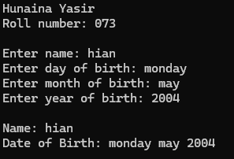
Date of Birth: monday may 2004

Exercise 5:
Pass a structure to a function to calculate the total and average marks of a student.
SOURCE CODE:
#include <iostream>
using namespace std;

struct Student {
int marks[3];
};

void calculate(Student s) {
int total = s.marks[0] + s.marks[1] + s.marks[2];
float average = total / 3.0;

cout << "Total Marks: " << total << endl;
cout << "Average Marks: " << average << endl;
}

int main() {
cout << "Hunaina Yasir" << endl;
cout << "Roll number: 073" << endl << endl;

Student s;

for (int i = 0; i < 3; i++) {
cout << "Enter marks: ";
cin >> s.marks[i];
}

calculate(s);

return 0;
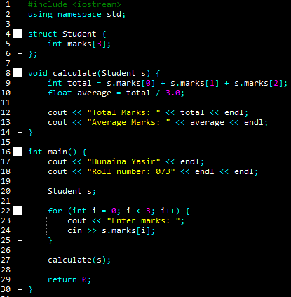
}
OUTPUT:
Hunaina Yasir
Roll number: 073

Enter marks: 45
Enter marks: 34
Enter marks: 234
Total Marks: 313
Average Marks: 104.333
